AI FitTrack – Personalized Fitness Recommendations powered by AI
Project Design Phase-II
Data Flow Diagram & User Stories
Date | 22/09/2026
Team ID | SWTID-2026-5251
Project Name | AI FitTrack
Team Leader: YACHEL C | Team Members: GOMATHI S, ABIRAMI R, JANANI D
Data Flow Diagram:
A Data Flow Diagram (DFD) is a traditional visual representation of the information flows within a system. It shows how data enters and leaves the system, what changes the information, and where data is stored. The diagram below traces a request from the client through authentication, business logic, and AI services, down to the database.
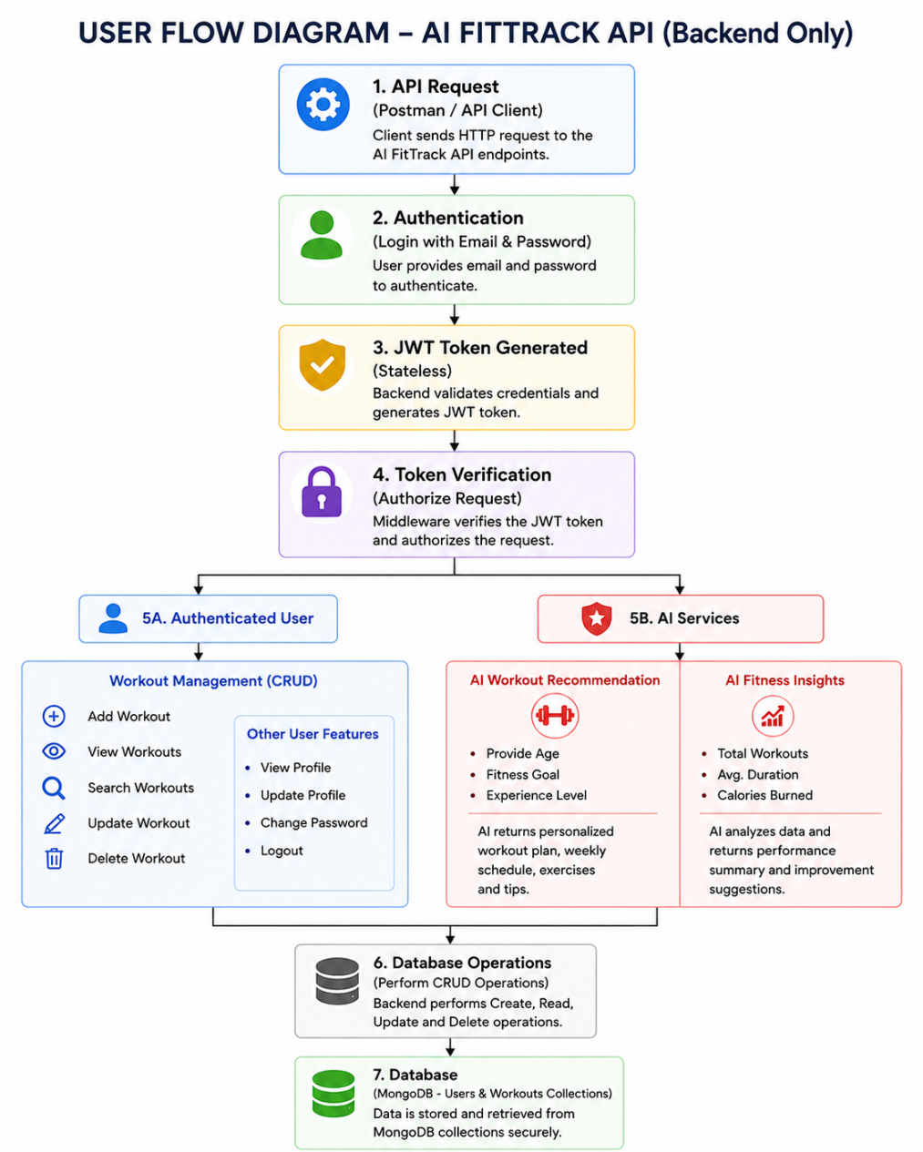
User Stories
Use the below template to list all the user stories for the product.
User Type | User Story Number | User Story / Task | Acceptance Criteria | Priority | Release
Authenticated User | USN-1 | As a user, I can register and log in securely using JWT authentication | User can create an account and receive a token after login | High | Sprint-1
Authenticated User | USN-2 | As a user, I can add new workouts to my history | Workout is saved and visible only to the logged-in user | High | Sprint-1
Authenticated User | USN-3 | As a user, I can view all my workouts in a list | Workouts load successfully with a valid token | High | Sprint-1
Authenticated User | USN-4 | As a user, I can update workout details like duration and calories | Changes are saved and reflected instantly | Medium | Sprint-2
Authenticated User | USN-5 | As a user, I can delete workouts from my history | Workout disappears from the list after deletion | Medium | Sprint-2
Authenticated User | USN-6 | As a user, I can search workouts by name, category, or date | Filtered results appear based on the search query | Medium | Sprint-2
Authenticated User | USN-7 | As a user, I can request an AI-generated workout recommendation | Providing age, goal, and experience returns a personalized plan | High | Sprint-3
Authenticated User | USN-8 | As a user, I can request AI fitness insights based on my stats | Providing workout statistics returns a motivational, data-driven insight | High | Sprint-3

